7. Advanced HCL: Meal Announcement (MA) via a pre-bolus… V2.6

Please note that with autoISF you are in an early-dev. environment, where the user interface is not optimized for safety of users who stray away from intended ways to use. Good safety features exist, but these are only as good as the development-oriented user understands and implements them. This is not a medical product, refer to disclaimer in section 0

Available related case studies:

Case study 7.1:
Case study 7.2:

See also Case study 13.3 from a user of Boost
7.1 Frequently encountered hurdles
7.2 Getting ready to advance
7.3 Reduced pre-bolus
7.4 Tuning autoISF in HCL
7.5 Dealing with disturbances/ins. sens/resistance
7.6 Exercise management
7.7 Remote control (small children)
7.8 Other methods w/ meal announcement (MA)

Originally it was planned to provide an extra section on FCL for kids here. However, we came to realize that the approach is no different for kids than already laid out. It just seems some implementation hurdles are significantly higher for implementing a safe FCL for minors.
For that reason, we like to explore in this section 7. how a hybrid closed loop without carb inputs, using autoISF, might get you to a solution that removes most of the everyday burden associated with having to co-manage meals.
This could (not only for kids) also be an intermediary step, from which to progress into FCL as soon as a currently missing pre-requisite resolves for you in the future.

7.1 Frequently encountered hurdles

Deficit making FCL difficult or unsafe | Bridging solution in Advanced HCL
Lyumjev or Fiasp (also in 50% mix w.slower insulin) not tolerated/too many occlusions; poor discipline re. scheduled infusion site changes | Difficult. Experiment with different insertion (site, depth, angle, cannula material), injection speed, site exchange frequency. (all difficult w/ pod pumps). Low carb diet
Discipline is poor regarding keeping 100% Bluetooth connectivity | Given bolus (and profile basal running) will reduce the problem significantly; alarm on parent phone
Leaking pods | (still a “no go”)
Jumpy CGM | Use strong smoothing
Very low hourly basal | No problem as HCL does not require super boosted SMBs
Erratic patterns of sweet drinks and snacks | Much less of a problem as a bolus is given with it

To establish and maintain any loop for kids brings about some extra challenges if:
- Going through marked changes of insulin sensitivity or of circadian pattern makes it difficult to keep the FCL appropriately tuned.
This problem is about the same in all loops (Autotune, self-learning systems etc…??). You should try to set appropriate (temp.?) changed profiles, that serve also as a basis for your autoISF loop.
- Between kid and supervising parent it must be guaranteed, especially in the initial weeks, that an eye is kept on whether the “Advanced HCL (MA) loop” is working about as to be expected.

7.2 Ready to advance?

Switch off dynamicISF, forget what Autotune tries to tell you, and make sure your profile parameters are set right. Refer to guidance given in the HCL repo here:

Optimize meal management, notably watch that your ISFs are set right to deal with rising bg once your given meal bolus looses power.

With properly set ISFs, you should be able to expand allowed SMBV sizes to 120 minutes worth of basal.

Next, introduce a method that allows your loop take care of temp. insulin resistance from fats. (In the past, dynamicISF might have helped you for that.)
Now you have two options:
- Temporary increase of %profile via an Automation at signs of post-meal fatty acid resistance. See: (readthedocs)
- Or step into using the AAPS dev variant with autoISF, but make exclusively use of the dura_ISF component there.

Make sure your HCL now works at satisfying performance.
In the next steps, you try to get same performance, but with only a very rough idea, what you will eat (and no carb inputs)

7.3 Reduced pre-bolussing

Note that by continuing to make (albeit reduced) boli at meal start we remain in Hybrid Closed Loop (HCL) territory. Do not boost your SMBs nearly as much as enabled if you already work with the AAPS dev variant, and advised in section 02 for FCL! Also, do

If users pre-bolus for kids …..always, or “forget” sometimes? How(much)? =>
Make sure to give details …
…. and possibly a warning, regarding implications for settings (I could imagine bgAccel_ISF-weight tuning should be factor 5 if not 10 milder in that case = … and not be good if sometimes you pre-bolus a bit, and sometimes not ????)

FCL => implications for remote parent monitoring ? (may have to come at the end, when all potential problems were discussed)

- Extra caution needed re. elevating the SMB delivery ratio ?
  - The fixed 0.5 value in AAPS was installed also with a consideration on user/follower (parent) set up and limiting potential problems from a bolus being initiated from both phones in parallel
  - As in FCL neither phone should initiate a manual bolus, this precaution seems not really needed (dev – check)

Discuss risk from a “loose” bolussing habit in MA
* shooting from the hip against highs …
* Need to learn interpret iob, insulin activity curve, prediction curves etc …
7.5 Dealing with special situations / insulin sensitivity / Disturbances 7.5.1 manually, via temp%profile and TT
7.5.2 via Automations 7.5.3 via custom buttons The DIY Cockpit (see quoted below, from section 5.2.2.3) allows to have buttons dedicated to kindergarten hours etc that can in a time-uncritical manner activate special routines – should be very helpful to custom program Automations for kids!
Grey extra DIY cockpit buttons for pre-programmed “responses”

Recognizing conditions for fully automatic handling by the loop may not be not possible, or come too late for the loop to act on. Examples would be
      - exercise: Minimum an hour before starting “the loop should know” to be able to lower iob and elevate bg by the time exercise starts.
      - snacks: High carb snacks, sweets, consuming ice cream or having a sweet drink comes with the problem of even steeper glucose rises, but overall a lesser insulin need, compared to major meals (for which we tuned our FCL according to section 4).

This not necessarily implies that snacks need different settings than a meal. After all, autoISF was designed to act to all available data, especially to where the developing glucose curve is headed. So, depending on your effort to set parameters for a broad variety of meals (notably: how well you avoid to invariably bounce fast against your iobTH), you might be able to accommodate low carb, snack, and major meals with one set of settings.

In FCL autoISF, this is a bit more difficult than in HCL autoISF applications, because FCL involves revving up iob supply (largely via big bgAccel_ISF-weights) often too much to be balanced by just a snack getting absorbed.

For that reason, or just for increased comfort and safety, you might want to differentiate, and make use of what follows for the sweet snack example.

Tuning aggressiveness
Key is that a sweet snack likely benefits from even more aggressive initial FCL performance than the meals in your normal spectrum of diets require.
Therefore, you could set
- a higher temp. profile% and/or
- a temp.elevated bgAccel_ISF-weight (see screenshot of my Automation).
- a low temp. target (76 for instance; this additionally helps maximize the first SMBs that will automatically be triggered at detection of acceleration)..

When first defining and testing this Automation, also check:
- that the safety limits as discussed in section 2 will not block the intended elevated aggressiveness
- SMBs will not get outrageously big and iobTH sometimes exceeded by too much
Note that “the last SMB” is allowed to overshoot the effective iobTH by 30%

Limiting iob
For “just a snack”, total insulin need will be lower than for a meal.
If you would just have your sweet drink, and your meal-oriented FCL would “attack”, iob likely would become too high, and a glucose rollercoaster would start, with you needing to consume more =>
If you just have a snack, or drink a glass of juice, you can lower the iobTH_percent accordingly.
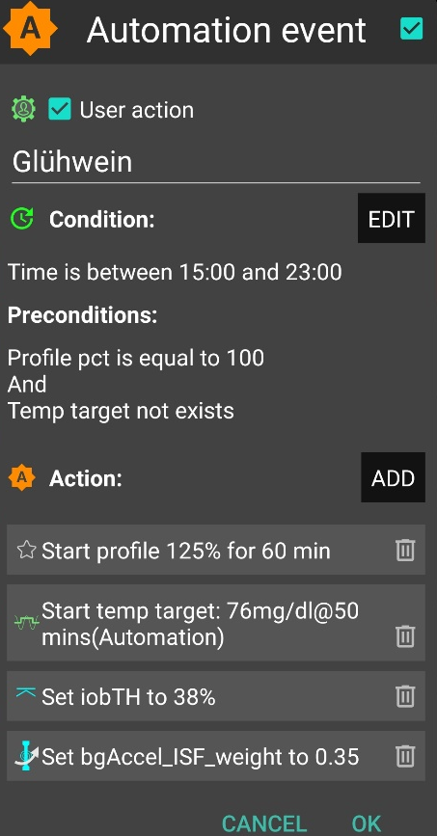
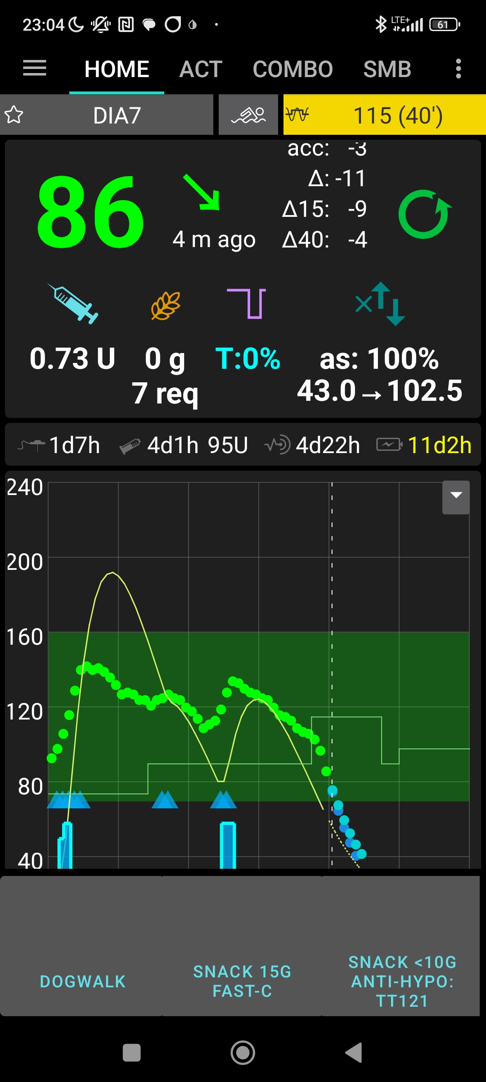
„User action“ is always ticked-on

This will, in the defined time space ..

..offer the “DIY cockpit” button..

..which I must press any time (~90…30 minutes) before my snack.

Note: Make sure that iobTH and bgAccel_ISF_weight revert to default afterwards
Snack 15g fast-C

So, this can be a little extra “project” when setting up your FCL.
You need to research your snack habits (if any), and over time find out which settings in the snack-related Automations work well.

In everyday life you then just must press the related button in your cockpit (which is not time critical at all, except it should be clicked latest a couple of minutes after you took the drink or snack).

If you consume more, and also eat something with your sweet drink, this will more resemble a full meal… however, with unusual amounts of fast carbs.

Note: Pressing your snack button a second time would not help because the lowered iobTH does not allow iob going high enough. So you are better off just letting your normal FCL meal routine run, after your snack mode expired.

Other options when snacks keep extending would require a manual modulation regarding %profile and/or bgAccel_ISF, but keeping the full default set iobTH_percent, or even elevating it (refer to section 5.2.3). If that happens often, define for yourself an extra User action Automation for a bigger snack (= another grey DIY cockpit button).

Caution: If (as in autoISF 3.0) setting a different iobTH or bgAccel_ISF_weight can not be done temporarily (i.e. with a duration attached) you must define a suitable additional Automation, that
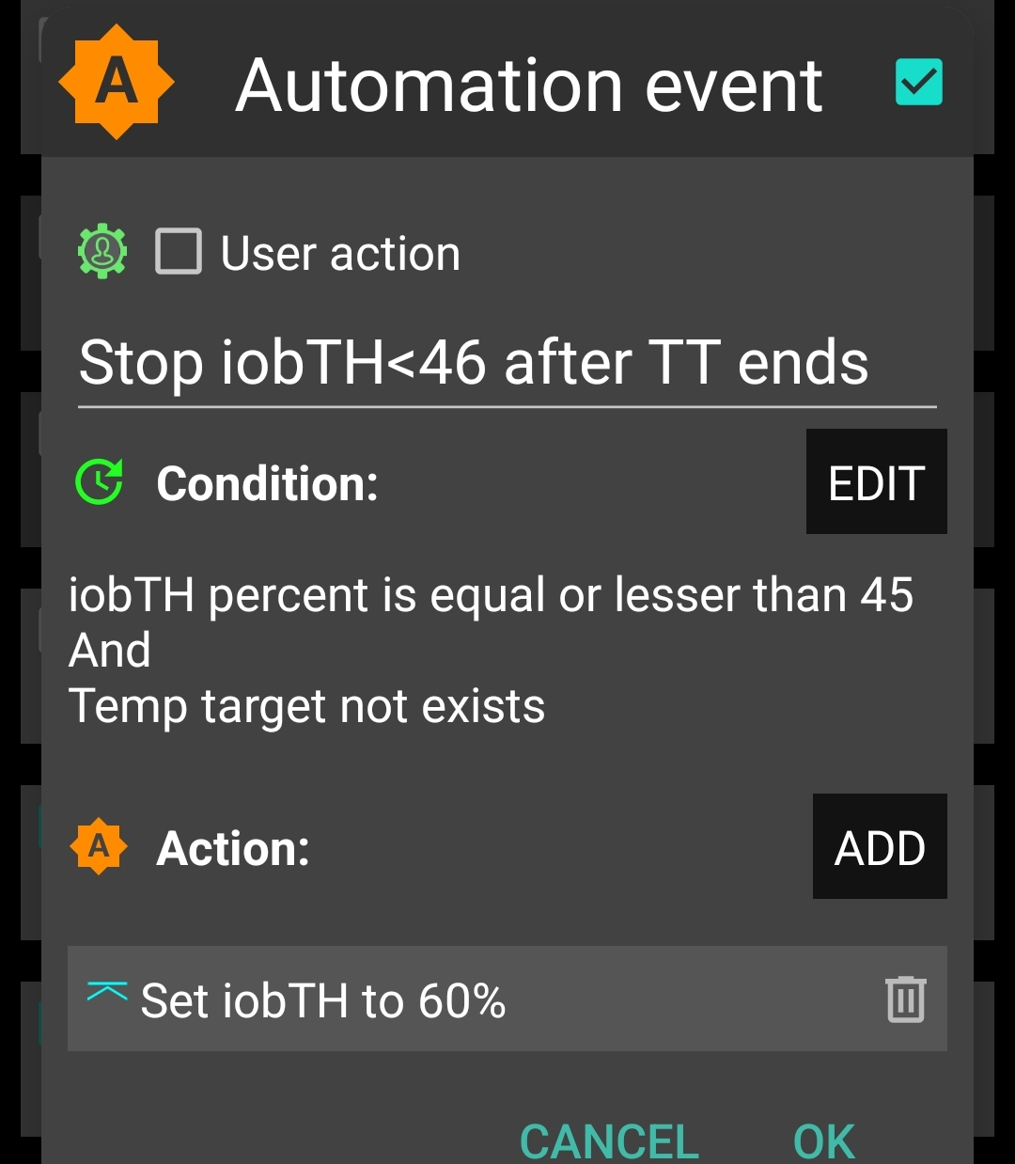
must be active in tandem, that restores the default set iobTH or bgAccel-ISF_weight again. Else, once your Automation set in, it will forever shift this important parameter setting!
If for instance you have several Automations that, in combination with a set elevated TT also set a lower iobTH: Don’t be fooled, the duration only applies to the TT. You need an extra Automation for all of them.
I picked out the highest of the altered iobTH values that these Automations can set (45_percent), and then I can automatically restore my default desired 60% via this one Automation (see screenshot - - > )

Installing the DIY cockpit button
In the related Automation, just keep the “User action” box clicked at all times, and define in the Conditions when you want to see that button available for cockpit use (see screenshot above) => you will see that button offered.

Besides snacks, also any other recurring special situations can be addressed via a DIY cockpit button, and receive different aggressiveness up to a suitable iobTH level.

Over time you can have a big number of User action Automations, and keep them “shelved” rather invisibly (clicked in-active, top left box) in your long list of potential Automations. Even when active, they only show in your cockpit (bottom grey field of your AAPS home screen) in the time slot you assigned as potentially relevant.

----------------------------------------radically need to shorten this quote from chapter 5.2.2.3 -------------------------------

End with something like:
There are a couple of parents and kids pioneering this area, see also Case studies 7.x.
We highlighted areas that would require some minimum compliance. In the end it comes down to compare the achieved ease in daily use and achieved %TIR to how it was when hybrid closed looping.

Re. pre-requisites, CGM, for kids: what works well ??
If not G6 is used: (re CGMs, observe latest developments re 1 minute vs 5 minute readings, see github/ga-zelle pls )

Pls include implications of (from wiki aaps):
Dexcom G6 or Dexcom ONE with xDrip+ Companion Modeℑ
The noise-level data is not shared with AAPS using this method. Therefore ‘Enable SMB always’ and ‘Enable SMB after carbs’ are disabled.
xDrip+ with FreeStyle Libreℑ
None of the FreeStyle Libre systems (FSL1, FSL2, or FSL3) broadcast any information about the level of noise detected in the readings, and therefore ‘Enable SMB always’ and ‘Enable SMB after carbs’ are disabled for all setups using the FreeStyle Libre.
In addition, many people have reported the FreeStyle Libre often produces noisy data. In xDrip+ there are a few options to help with this:
Smooth Sensor Noise. In xDrip+ Settings > xDrip+ Display Settings ensure that Smooth Sensor Noise is turned on. This attempts to apply smoothing to noisy data.
Smooth Sensor Noise (Ultrasensitive). If you are still seeing noisy data in xDrip+ you can apply more aggressive smoothing using the Smooth Sensor Noise (Ultrasensitive) setting. This will attempt to apply smoothing even on very low levels of detected noise. To do this, first enable engineering mode in xDrip+. Then navigate to Settings > xDrip+ Display Settings and turn on Smooth Sensor Noise (Ultrasensitive).

